Task 2 (Google Firestore web app)

Student name: Md Mostak Laheri
Student ID: 2511809
Submission Date: 29/04/2026
1: Add Button Evidence 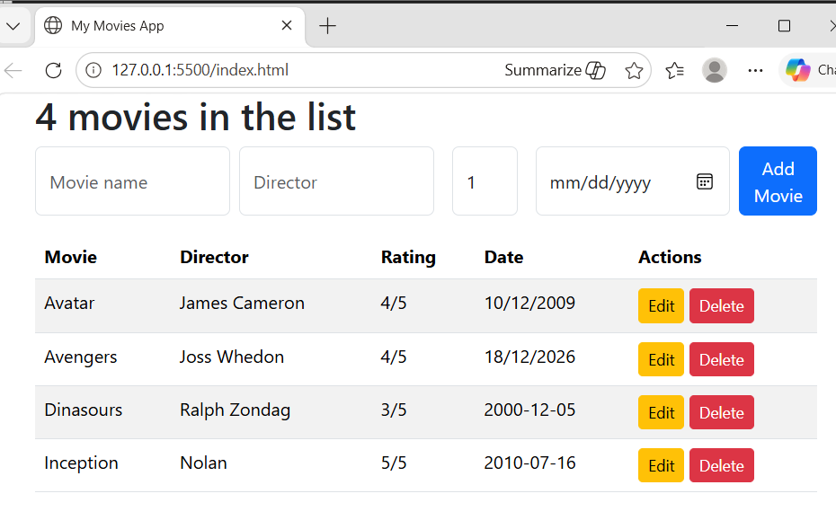

2: Movies collection Evidence
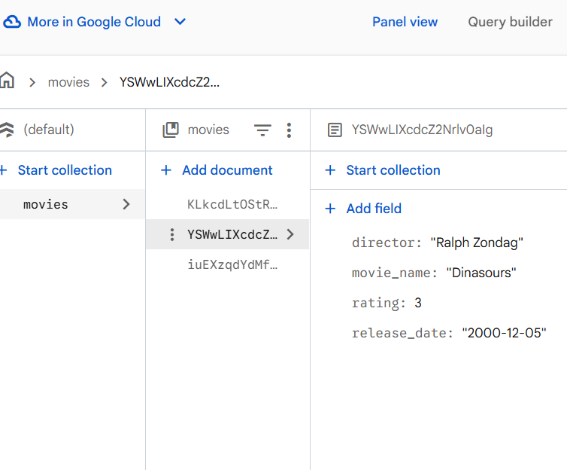
3: Delete Button Evidence 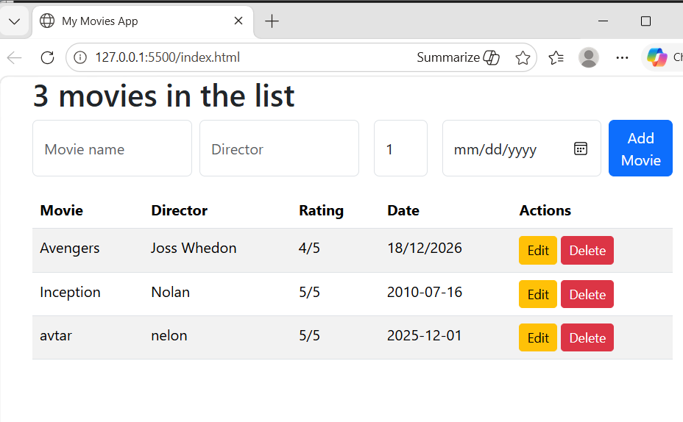

4: Edit Button Evidence 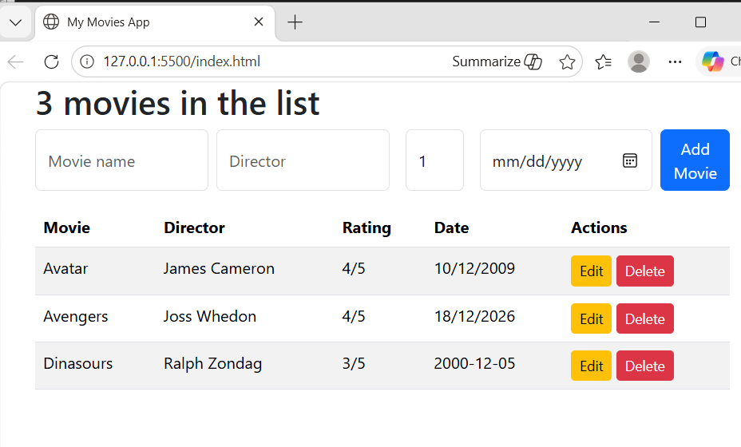
5: Sort by Name Evidence 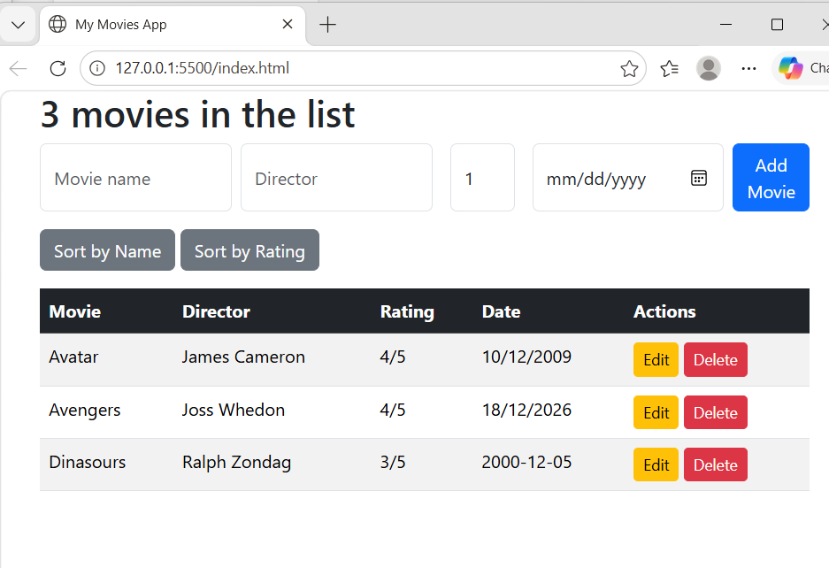

6: Sort by rating Evidence 